**Exercise 1:**

**Part 1:**

Q1.

A null hypothesis predicts that the experimental manipulation will have no effect. E.g. if there are two tests, the null hypothesis states that there will be no difference between participants’ performance in the two treatments. The null hypothesis is assumed to be true until you find convincing evidence to reject it.

Q2.

The variable is scale.

Q3.

A Type I error is when we conclude that there is a meaningful effect in the population when in fact there is not.

Q4.

A positive value of skewness indicates that the scores are piled up on the left hand side of the distribution.

**Part 2:**

Q5

(a) A measure of central tendency is a single value that tries to describe a set of data by identifying the central or typical value for that set of data. The most common measures of central tendency are the mean, the median and the mode but under different conditions, some measures are more appropriate to use than others.

(b) The mean (often referred to as the 'average') is the sum of all the values in the data set divided by the number of values in the data set. E.g. the mean of the numbers 1, 2, 3, 6, 8 is 20 / 5 = 4. An important property of the mean is that it includes every value in the data set as part of the calculation. The mean has one main disadvantage: it is susceptible to the influence of outliers. These are values that are unusual compared to the rest of the data set by being especially small or large in value.

The mode is the most frequent score in a data set. E.g. the mode of the numbers 3, 5, 9, 2, 5, 7, 2, 8, 1, 2 is 2 as this number occurs 3 times. This is the only central tendency measure that can be used with nominal data.

The median is the middle score for a data set that has been arranged in order of magnitude. It can be thought of as, the middle value that separates the higher half of the data set from the lower half.

E.g. to find the median of the following numbers:

65 55 89 56 35 14 56 55 87 45 92

we first re-arrange the number in order of magnitude:

14 35 45 55 55 56 56 65 87 89 92

The median score here is 56. If there were an even number of numbers then to get the median you take the middle two scores and average the result.

Q6.

|  |  |  |
| --- | --- | --- |
| **Statistics** | | |
| Age | | |
| N | Valid | 150 |
| Missing | 9 |
| Mean | | 22.60 |
| Median | | 21.00 |
| Mode | | 20 |

The mean or average age is 22.60 years.

The median age (the age that occurs in the middle of the ages when they are arranged in order of magnitude) is 21. This is lower than the mean and shows that there are some higher ages that are affecting the mean.

The mode (the age that occurs most often) is 20 years.

**Part 3.**

Q7.

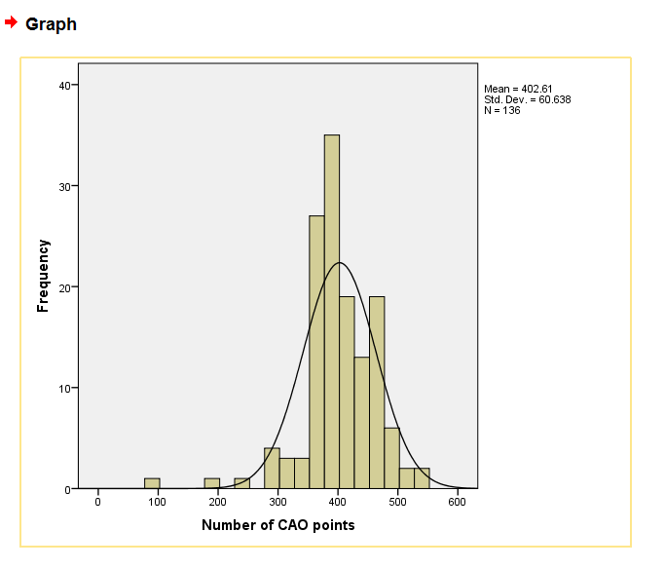

Q8.

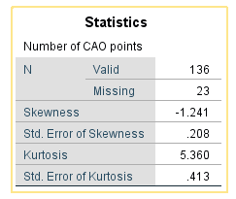

The Skewness is -1.241. This value provides an indication of the symmetry of the distribution. Here we have negative skewness which indicates a clustering of scores at the high end (right-hand side of a graph). Although an acceptable range for skewness according to Tabachnick & Fidell (2013) is between -1.5 and +1.5.

The Kurtosis is 5.360. This provides information about the ‘peakedness’ of the distribution. It is measured against the standard normal distribution. The standard normal distribution has a kurtosis of 3. Here we have a positive kurtosis value which indicates that the distribution is rather peaked (clustered in the centre), with long thin tails.

Q9.

The distribution for CAO point is fairly normal. The mean is 402.61, the mode is 400 and the median is 400. The skewness is within acceptable ranges. The Kurtosis is slightly 'peaked', meaning that the data is clustered in the center. A kurtosis value for a normal distribution is 3.

**Part 4**

Q 10.

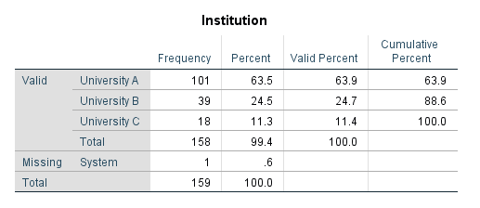

This table shows that the majority of students attended University A (63.5 percent). The next most popular university was University B (24.5 percent). With University C having only 11.3 percent. University's A and B had a combined 88.6 percent of the participant. The table also shows that 158 of the 159 participant answered the question about which university they went to but one participant failed to fill out which university they went to.

Q 11

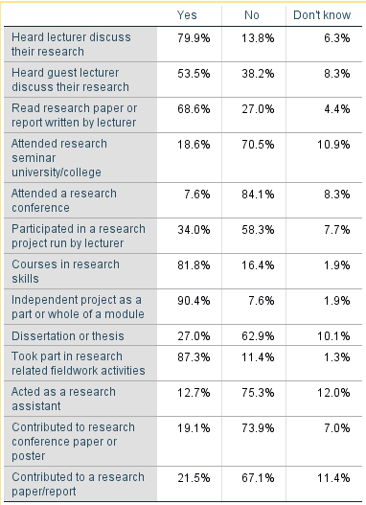

The most popular research activity was an 'Independent project as a part or whole of a module (90.4 percent). This was followed by 'taking part in research related fieldwork' (87.3 percent). The least popular research activity was 'attending a research conference (only 7.6 percent did this). The second lest popular research activity was 'acting as a research assistant (12.7 percent).

**Exercise 2:**

**Part 1.**

Q 1.

In an independent subjects design answer C is correct. Different participants perform in each condition.

Q 2.

The independent variable (teaching method) has 3 levels. In general, the number of levels of an independent variable is the number of experimental conditions. So in this case there are three experimental conditions i.e. tuition via large lectures, small tutorial groups or online podcasts.

Q 3.

An advantage of repeated measures designs is B, greater control over potential confounding variables.

**Part 2.**

Q 4.

(a) 'Gender' is the independent variable and has two levels (male or female). The dependent variable is anxiety scores and has 1 level.

(b) The null hypothesis is: there is no difference between males and females in terms of research anxiety scores.

The alternative hypothesis is: there is a difference between males and females in terms of research anxiety scores.

(c) The kind of data is gathered for the dependent variable is ratio data (numerical)..

(d) A parametric test would be appropriate as the data is normally distributed and Parametric tests assume normal (or near normal) distributions. The skewness is -0.245 and the kurtosis is -0.509. The acceptable range for skewness or kurtosis is below +1.5 and above -1.5 (Tabachnick & Fidell, 2013).

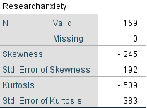

Also the Homogeneity of variance is 0.547. Here we are hoping to find that the test is not significant (i.e. a significance level of greater than .05) which is the case with this data.

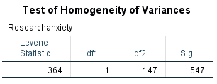

Q 5.

As the data is parametric we can use Independent-samples t-test, Paired-samples t-test, One-way between-groups ANOVA, One-way repeated-measures ANOVA, Two-way analysis of variance (between groups), Mixed between-within groups ANOVA, Multivariate analysis of variance (MANOVA), Analysis of covariance.

As we want to compare the mean scores of two different groups of people for our analysis, we will use independent samples t-tests.

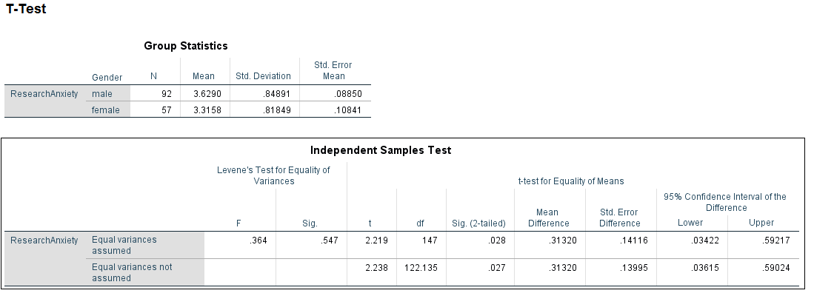

As the Sig. value for Levene’s test is larger than .05 (ours is .547) we use the first line in the table, which refers to Equal variances assumed.

(a) The value in the Sig. (2-tailed) column is equal to or less than .05 (ours is 0.028), which means that there is a significant difference between each of the two groups. The t-test value is 2.219

(b) This result implies that males are more likely to suffer research anxiety that females.

(c) We have an Alpha of 5%, which means that we have a 5% probability of incorrectly rejecting the null hypothesis. We are 95% confident that the mean difference between males and females is between 0.03422 and 0.59217

**Part 3.**

Q 6.

(a) Anxiety score is the dependent variable in both tests. The independent variable is time.

(b) The null hypothesis are:

There a no difference between males’ research anxiety scores between Time 1 and Time 2? Is there no difference in females’ research anxiety scores Time 1 and Time 2?

The alternative hypothesis are:

There a difference between males’ research anxiety scores between Time 1 and Time 2? There a difference in females’ research anxiety scores Time 1 and Time 2?

(c) The type of data is ratio data (numerical).

(d) For the males a parametric test (repeated measures design such as 'paired samples t-test') would be appropriate as the data is normally distributed. The skewness is -0.374 for Research Anxiety and -0.078 for Research Post and the kurtosis is -0.561 for Research Anxiety and -0.473 for Research Post. The acceptable range for skewness or kurtosis is below +1.5 and above -1.5 (Tabachnick & Fidell, 2013).

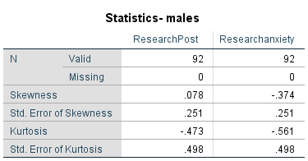

For the females a parametric test (repeated measures design such as 'paired samples t-test') would also be appropriate as the data is again normally distributed. The skewness is -0.025 for Research Anxiety and -0.078 for Research Post and the kurtosis is -0.209 for Research Anxiety and -0.2193 for Research Post. The acceptable range for skewness or kurtosis is below +1.5 and above -1.5 (Tabachnick & Fidell, 2013).

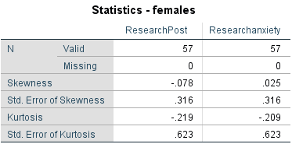

Q 7.

(a) I have done two tests here. One for each question:

1. Is there a difference in males’ research anxiety scores between Time 1and Time 2?
2. Is there a difference in females’ research anxiety scores Time 1and Time 2?

For question 1 the t-test score is -0.4981. If the value in the Sig. (2-tailed) column is equal to or less than .05 (ours is 0.000), which means that there is a significant difference between scores for time 1 and time 2 for males.

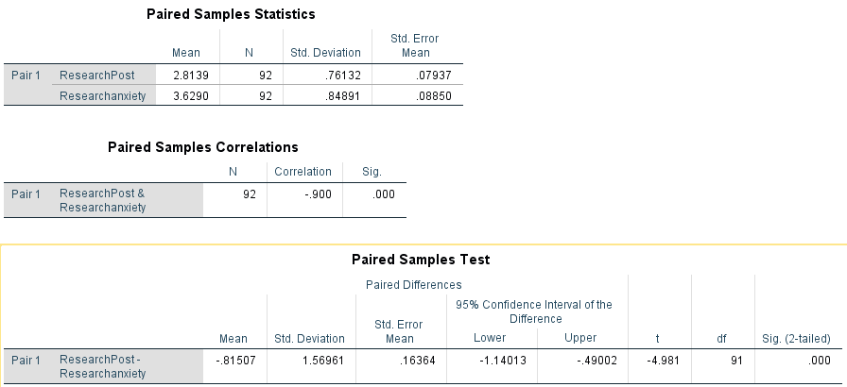

For question 2 the t-test score is -0.855. The value in the Sig. (2-tailed) column is equal to or greater than .05 (ours is 0.396), which means that there is no significant difference between scores for time 1 and time 2 for females.

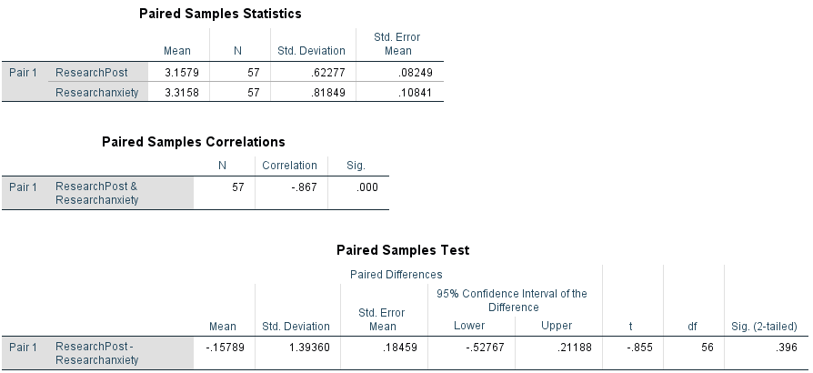

(b) For question 1 the value in the Sig. (2-tailed) column is equal to or less than .05 (ours is 0.000), which means that there is a significant difference between scores for time 1 and time 2 for males. The mean for Research post is 2.8139 and the mean for Research Anxiety is 3.6290 so we can say that the anxiety score has gone down after the intervention for males.

For question 2 there is no significant difference so we can say that the intervention made no difference for females.

(c) For question 1, the sample size of males is 92. We have an alpha value of .05 and the significance is 0.000. Zero is not in the range for the upper and lower confidence intervals so we can be confident that the result is not a type 1 error (false positive)

For question 2, zero is in the range for the upper and lower confidence intervals so this confirms that the result is not significant. Therefore we can't have a false positive.

**Exercise 3**

**Part 1.**

Q 1.

The lowest expected frequency in any cell for a chi-square test for independence is 5.

If the cell frequency were lower this means that the sample size is unsuitable (too small) for chi-square analysis

Q 2.

The number of dependent variables a two-way ANOVA has is one dependant variable.

Q 3.

If a study has employed a two-way mixed ANOVA, it means that there was a repeated measures factor and an independent measures factor in the study.

A ‘repeated-measures ANOVA’ contains only within participants variables (where

participants take part in all conditions) and an ‘independent ANOVA’ uses only

between participants variables (where participants only take part in one condition),

'Mixed ANOVA' contains BOTH variable types.

Q 4.

Chi-square test for independence allows the researcher to test for differences between two categorical variables.

**Part 2**

Q 5.

(a) The null hypothesis is:

There is no association between male and female students and the level of mathematics taken at leaving certificate.

The alternative hypothesis is:

There is an association between male and female students and the level of mathematics taken at leaving certificate.

(b) The appropriate test statistic to report if the test is significant is:

Asymp. Sig. (2-sided). (We would use the Continuity Correction score if it was a 2 X 2 grid.)

If the score is greater than 0.05 then the result is significant.

Q 6.

(a)

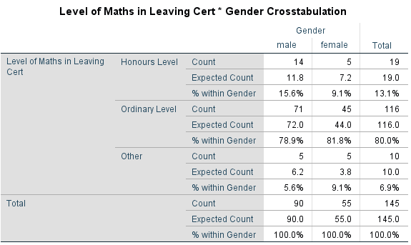

(b) The significance is 0.418 and the test value is 1.744

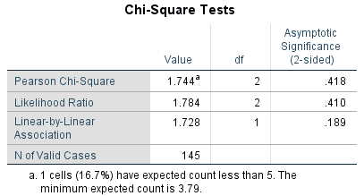

(c) We have a significance level of .418 which is greater than our cut off value of 0.05. The result is not significant and in this case we have to accept the null hypothesis.

If the result was significant we would use Cramer’s V. Our Cramer’s V score is 0.418 and the number of categories in the smaller of the two variables (gender) is 2. So from the table the effect would be medium.

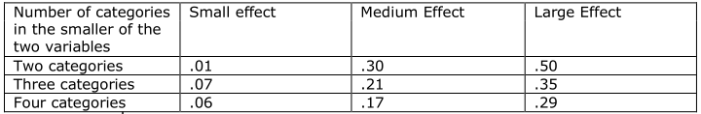

(d) As we have a significance level of .418 which is greater than our cut off value of 0.05. The result is not significant and in this case we have to accept the null hypothesis, that 'there is no association between male and female students and the level of mathematics taken at leaving certificate'.

(e) We could recode it so that the 'other' maths scores are grouped with the 'ordinary level scores. Which would give results as follows: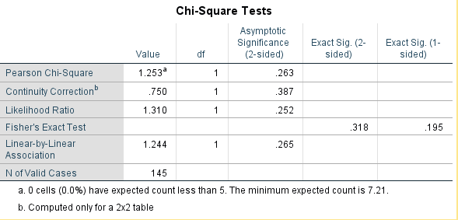

As this is a 2 X 2 grid we look at the Continuity Correction score. It is 0.263, which is greater the 0.05, so in this case we would have to accept the null hypothesis.

We could also recode it to omit the other scores altogether. Which would give results as follows:

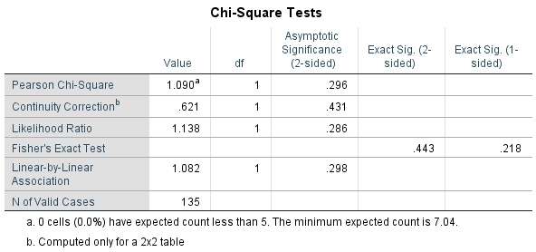

As this is a 2 X 2 grid we look at the Continuity Correction score. It is 0.621, which is greater the 0.05, so in this case we would have to accept the null hypothesis.

**Part 3**

Q 7.

(a) The independent variable is age. It has 3 levels.

The dependent variable is anxiety score.

(b) The null hypothesis is: There is no difference in research anxiety scores for students who are under 30yrs, 30-39yrs and 40+yrs.

The alternative hypothesis is: There is a difference in research anxiety scores for students who are under 30yrs, 30-39yrs and 40+yrs.

(c) The appropriate test is a 1-way between groups ANOVA. The '1-way' in the title indicates that only one independent variable is being considered. In this test the independent variables can have 3+ levels.

(d) The main assumptions are:

**Level of measurement:** the dependent variable should be measured at interval or ratio level. It must use continuous scores instead of distinct categories. The scores must be suitable for calculating mean and variance. This makes nominal or categorical dependent variables unsuitable for ANOVA. The dependent variable, anxiety score, is a continuous variable.

**Random sampling:** the participants represent a truly random sample of the overall population. The sample size is large so we can assume that this is true.

**Number of groups:** two groups at a minimum are required for ANOVA. In this test we have 3 groups, <30yrs; 30-39yrs; 40+yrs.

**Sample size:** The larger the sample size, the smaller the sampling error and the more reliable the measure. As ANOVA can work on more than two groups, each group should have a reasonable number of participants in each group. In this case we do not have a reasonable number in each group.

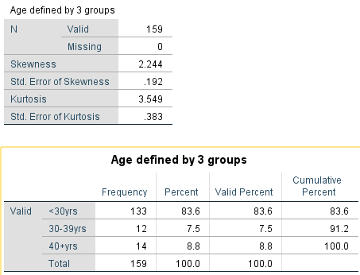

Here we can see that the data is skewed (skewness is 2.244). The <30yrs age group has 83.6 percent of the participants.

**Independence of groups:** if using an independent groups design, participants can only be in one group. In this case that is true.

**Independence of observations:** Participants should not be drawn from groups where they can influence each other’s scores. e.g., same class, family, etc. In this case it is not known if the participants are drawn from different groups.

**Homogeneity of variance:** If we want to compare 3 or more groups, we usually want to know if they have different means. This requires that the variances are equal for all groups.  
This assumption is fine if you have approximately equal sample sizes for each group. If however, group sizes are highly different, then we need to make sure that homogeneity of variances is me. Levene's test is used to find this out.

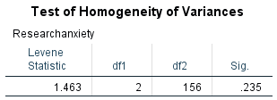

Here we have a significance score of 0.235. As this is greater than **0.05, we can say that the variances are equal.**

**Normal distribution: it is assumed that the populations from which the samples are drawn are normally distributed. It is also assumed that the dependent variable is normally distributed.**

Q8.

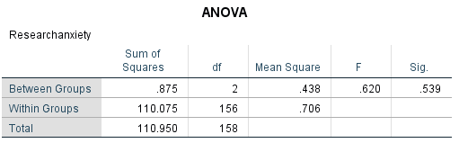

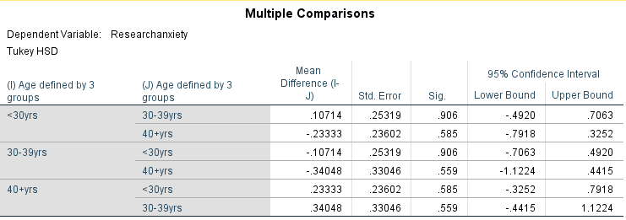

(a) The significance is 0.539. As this is greater than 0.05 we can say that there is no significant result. The f score is 0.620. As this is below 1 it confirms that there is no significant result.

From the Multiple Comparisons table we can see that all the significances are greater than 0.05, which again confirms that the result confirms the null hypothesis.

(b) The implication is that the age group the participant is in has no effect on their anxiety score. The null hypothesis holds: There is no difference in research anxiety scores for students who are under 30yrs, 30-39yrs and 40+yrs.

(c) A Type 1 Error is when we reject the null hypothesis when it is in fact true. As we are accepting the null hypothesis we won't have a type 1 error. Both the significance score of 0.539 (greater than 0.05) and the fact that 0 is between the lower and upper bound of the 95% confidence (Tukey HSD) interval backup the decision to accept the null hypothesis.

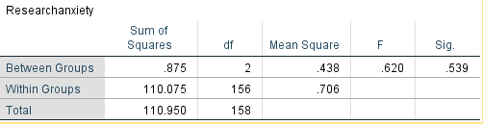

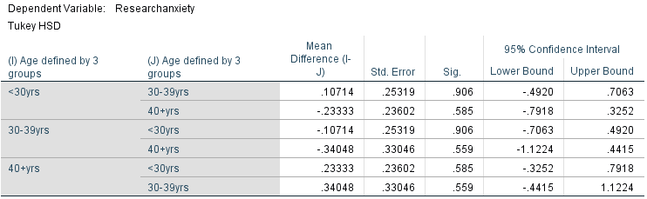

**References**

Tabachnick, B. and Fidell, L. 2013. Using Multivariate Statistics. 6th ed. Pearson.